

**Capstone Project Report**

**Report 6 – Software User Guides**

– Hanoi, December 2022 –

**Table of Contents**

I. Record of Changes 3

II. Release Package & User Guides 4

1. Deliverable Package 4

2. Installation Guides 4

2.1 System Requirements 4

2.2 Installation Instruction 4

3. User Manual 4

3.1 Overview 4

3.2 Workflow 1 4

3.3 Workflow 2 4

# I. Record of Changes

|  |  |  |  |
| --- | --- | --- | --- |
| Date | A* M, D | In charge | Change Description |
|  |  |  |  |
|  |  |  |  |
|  |  |  |  |
|  |  |  |  |
|  |  |  |  |
|  |  |  |  |
|  |  |  |  |
|  |  |  |  |
|  |  |  |  |
|  |  |  |  |
|  |  |  |  |
|  |  |  |  |
|  |  |  |  |

*A - Added M - Modified D - Deleted

# II. Release Package & User Guides

## 1. Deliverable Package

*[The section will list all source programs, scripts, documents with version number in this release. You can see the example following table for reference, can customize or delete if not using belong to each project characteristics]*

| **No.** | **Deliverable Item** | **Description** |
| --- | --- | --- |
| 1 | Project Schedule/Tracking |  |
| 2 | Project Backlog |  |
| 3 | Source Codes |  |
| 4 | Database Script(s) |  |
| 5 | Final Report Document |  |
| 6 | Test Cases Document |  |
| 7 | Defects List |  |
| 8 | Issues List |  |
| 9 | Slide |  |

## 2. Installation Guides

### 2.1 System Requirements

*[Define any system requirements necessary to support the application, including the software and relevant configurations]*

### 2.2 Installation Instruction

*[Includes installation instructions and configuration guidelines]*

## 3. User Manual

### 3.1 Overview

This user guide will provide detailed instructions for user features according to each role (Guest, User, Landlord, Staff, Admin) when accessing the FU House Finder website https://fuhousefinder.com

### 3.2 Web application

**3.2.1 Authentication**

**3.2.1.1 Sign in**

Role:(User, Landlord, Staff, Admin) - Web user sign in to the system

Step 1: Open website

Step 2: Click on “Đăng nhập” button



Step 3: Users fill all required information (username and password) or login with facebook and google into the form and click the “Đăng nhập” button.



Step 4: Select role.



a. System redirect to Home page if user selects student



b. System redirect to Landlord page if user selects landlord

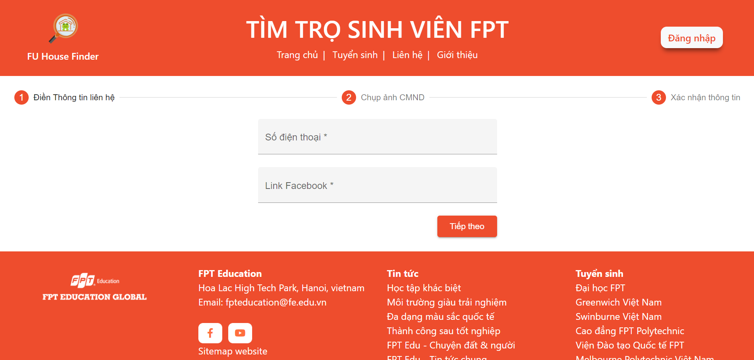

**3.2.1.2 Sign out**

Step 1: On Header in Home page, click on “Đăng xuất” button



Step 2: Redirect to Home Page



**3.2.2 Guest/User**

**3.2.2.1 Filter house (name, price, distance, campus, district, commune, village, room type, house utility, room utility, rate)**

Role: (User/ Guest)

Step 1: Sign in with role is User



Step 2: In Home page select filter







Step 3: Show list houses found



**3.2.2.2 Register to request a room**

Role: (User)

Step 1: Sign in with role is User



Step 2: In Home page click on “Đăng ký yêu cầu phòng trọ” on bottom



Step 3: Input information in modal and click on “Gửi yêu cầu” button to send request



Step 4: Show message “Thay đổi thông tin thành công”



**3.2.2.3 View Houses Detail**

Role: (User/ Guest)

Step 1: Sign in with role is User



Step 2: In Home page click on house want to view detail house



Step 3: Redirect to House detail page







**3.2.2.4 Rate and comment**

Role: (User/ Guest)

Step 1: Sign in with role is User



Step 2: Rate and comment the house



Step 3: Click on “Đăng” button to send rate and comment



Step 4: Show message “Bình luận thành công”



**3.2.2.5 View Map**

Role: (User/ Guest)

Step 1: Sign in with role is User



Step 2: In house detail, click on the map



Step 3: Show map



**3.2.2.6 Report house**

Role: (User)

Step 1: Sign in with role is User



Step 2: Click the icon on bottom



Step 3: Input information in modal and click on “Gửi yêu cầu” button to send request



**3.2.2.6 View room detail**

Role: (User/ Guest)

Step 1: Sign in with role is User



Step 2: In House detail page click on room want to view detail room



Step 3: Redirect to Room detail page





**3.2.3 Staff**

**3.2.3.1 View dashboard**

Role: (Staff)

Step 1: Sign in with role is Staff



Step 2: Redirect to Dashboard page





**3.2.3.2 View List Landlords**

Role: (Staff)

Step 1: Sign in with role is Staff



Step 2: Click on “Danh sách chủ trọ” on header



Step 3: Redirect to List Landlord page



**3.2.3.3 View Landlord Detail**

Role: (Staff)

Step 1: Sign in with role is Staff



Step 2: click on landlord want to view detail



Step 3: Redirect to Landlord Detail page



**3.2.3.4 View House Detail**

Role: (Staff)

Step 1: Sign in with role is Staff



Step 2: click on house want to view detail



Step 3: Redirect to House Detail page



**3.2.3.5 View Room Detail**

Role: (Staff)

Step 1: Sign in with role is Staff



Step 2: click on room want to view detail



Step 3: Redirect to Room Detail page





**3.2.3.6 View List Houses**

Role: (Staff)

Step 1: Sign in with role is Staff



Step 2: Click on “Danh sách nhà trọ” on header



Step 3: Redirect to List House page



**3.2.3.7 View List Reports**

Role: (Staff)

Step 1: Sign in with role is Staff



Step 2: Click on “Báo cáo” on header



Step 3: Redirect to List Report page



**3.2.3.8 Filter Reports**

Role: (Staff)

Step 1: Sign in with role is Staff



Step 2: Filter report





Step 3: Show list reports found





**3.2.3.9 View List Requests**

Role: (Staff)

Step 1: Sign in with role is Staff



Step 2: Click on “Chủ trọ đăng ký” on header



Step 3: Redirect to List Request page



**3.2.3.10 View List Orders**

Role: (Staff)

Step 1: Sign in with role is Staff



Step 2: Click on “Nguyện vọng” on header



Step 3: Redirect to List Order page





**3.2.3.11 Filter Orders**

Role: (Staff)

Step 1: Sign in with role is Staff



Step 2: Filter order



Step 3: Show list orders found



**3.2.3.12 Update profile**

Role: (Staff)

Step 1: Sign in with role is Staff



Step 2: Click on “Chỉnh sửa thông tin” on header



Step 3: Update name and email and click on “Thay đổi” button



Step 4: Show message “Cập nhật thành công”



**3.2.3.13 Change password**

Role: (Staff)

Step 1: Sign in with role is Staff



Step 2: Click on “Đổi mật khẩu” on header



Step 3: Update password and click on “Thay đổi” button



**3.2.4 Admin**

**3.2.4.1 View list staffs**

Role: (Admin)

Step 1: Sign in with role is Admin



Step 2: Redirect to List Staff page



**3.2.4.2 Add new staff**

Role: (Admin)

Step 1: Sign in with role is Admin



Step 2: Click on “Thêm mới” button



Step 3: Redirect to Create Account page, input information of staff and click on “Tạo mới” button



**3.2.4.3 Update staff**

Role: (Admin)

Step 1: Sign in with role is Admin



Step 2: Click on icon on table



Step 3: Redirect to Update Account page, input information of staff want to change and click on “Thay đổi” button

